- Begin by rolling out a small amount of clay | - Cut out a circle with a cookie cutter to form the base of the pot
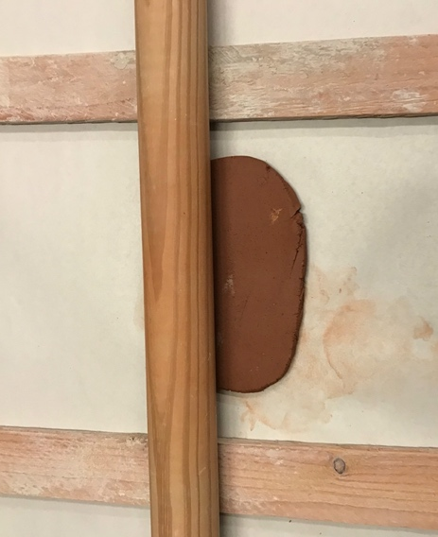 | 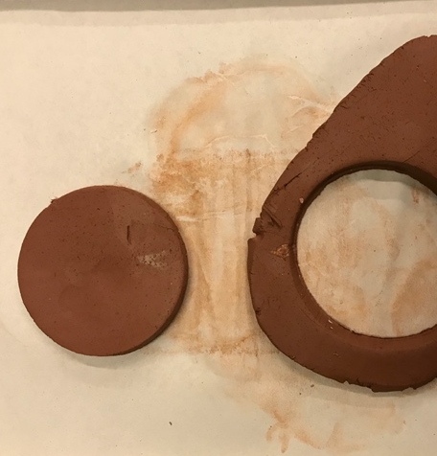
- Make a long rope of clay | - Score both the outside edge of the base and the bottom of the clay snake with a wooden needle tool
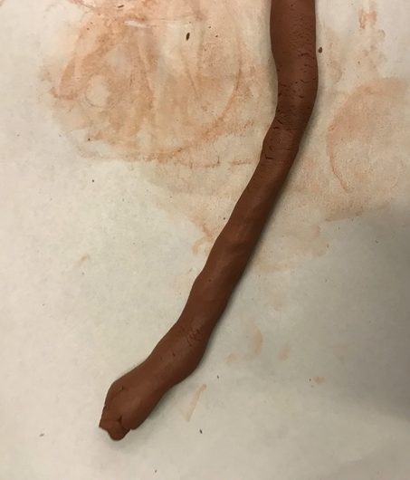 | 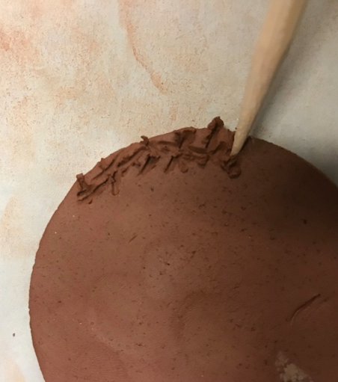
- Attach with a small amount of water | - Repeat for each coil until the desired height is reached
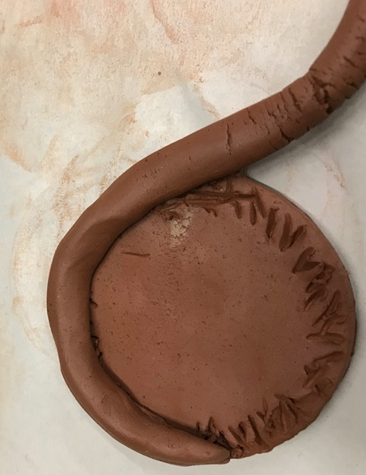 | 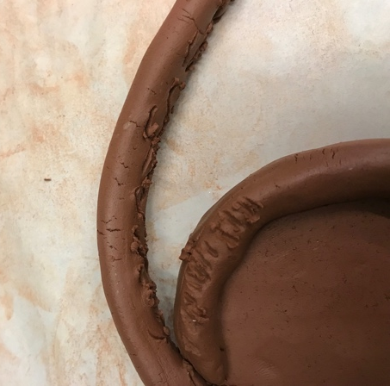

- Use a finger or wooden spatula to smooth the inside and ensure the bottom coil is firmly attached to the base

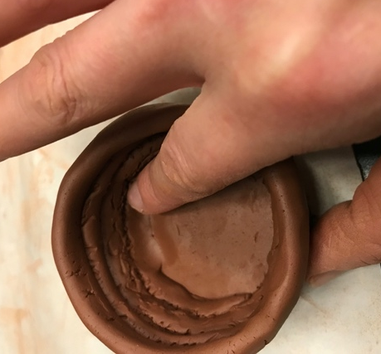 | 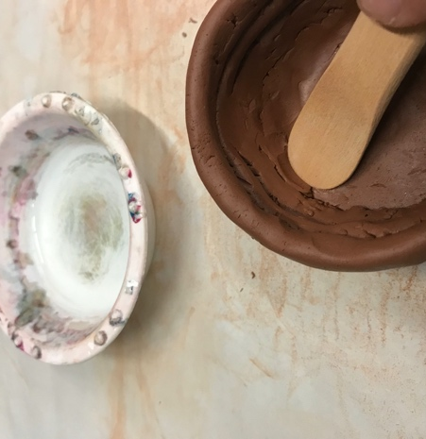
- Done!

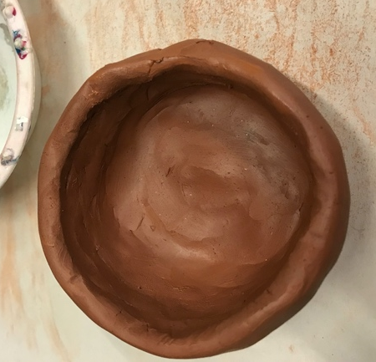 | 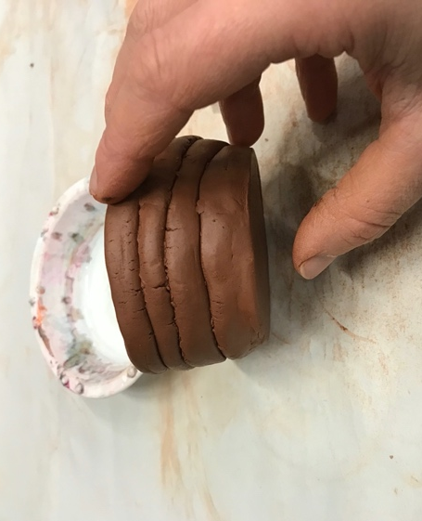
- Make sure to scratch the student’s initials/name and year on the bottom with a wooden needle tool | 